

Personal Speed Dials:

From your display telephone:

Note: Enter a 9 for the “Dial a line or group access code”

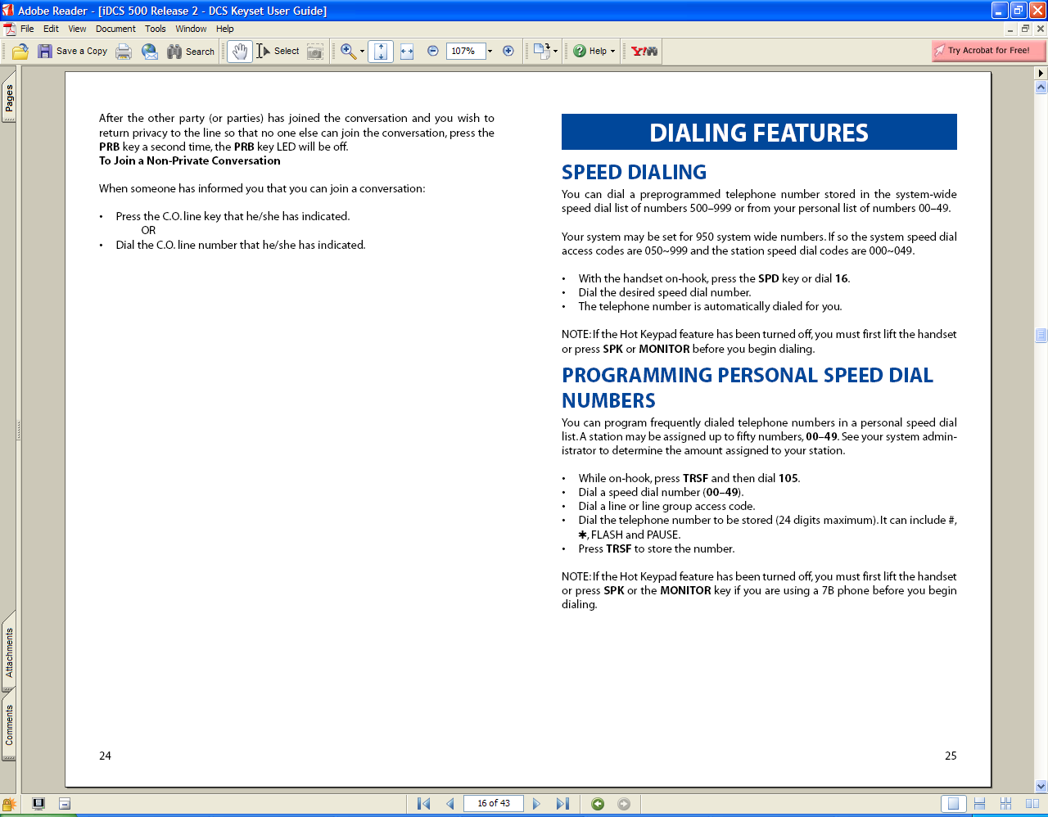

System Wide Speed Dials:

(From any display telephone)

Note: Enter a 9 for the “Dial a line or group access code”
- Press transfer 800
- Type 22911
- Press Transfer.
- Follow below steps

